**How the game will be played:**

The Player will press arrow keys to move the tiles.

The Press "up" key to rotates a tile counterclockwise.

Press "left" and "right" key presses to move tiles in corresponding direction.

Press "down" key to accelerate the downward movement.

The Player will press 'q' key to quit the game in case you see yourself failing.

The Player will press 'r' key to restart the game**.**

**Adding’s:**

When a new tile is dropping, it will show up row by row from the top of the game window.

Game will terminate if a new tile piece cannot be fit within the game window or it was stacked on the top row.

**HOW THE GAME WORKS.**

Tetris game is played on a grid with 20 rows and 10 columns (20,10).

The origin is the top left cell at (0,0).

We will represent the game grid using a 2-Dimensional integer array.

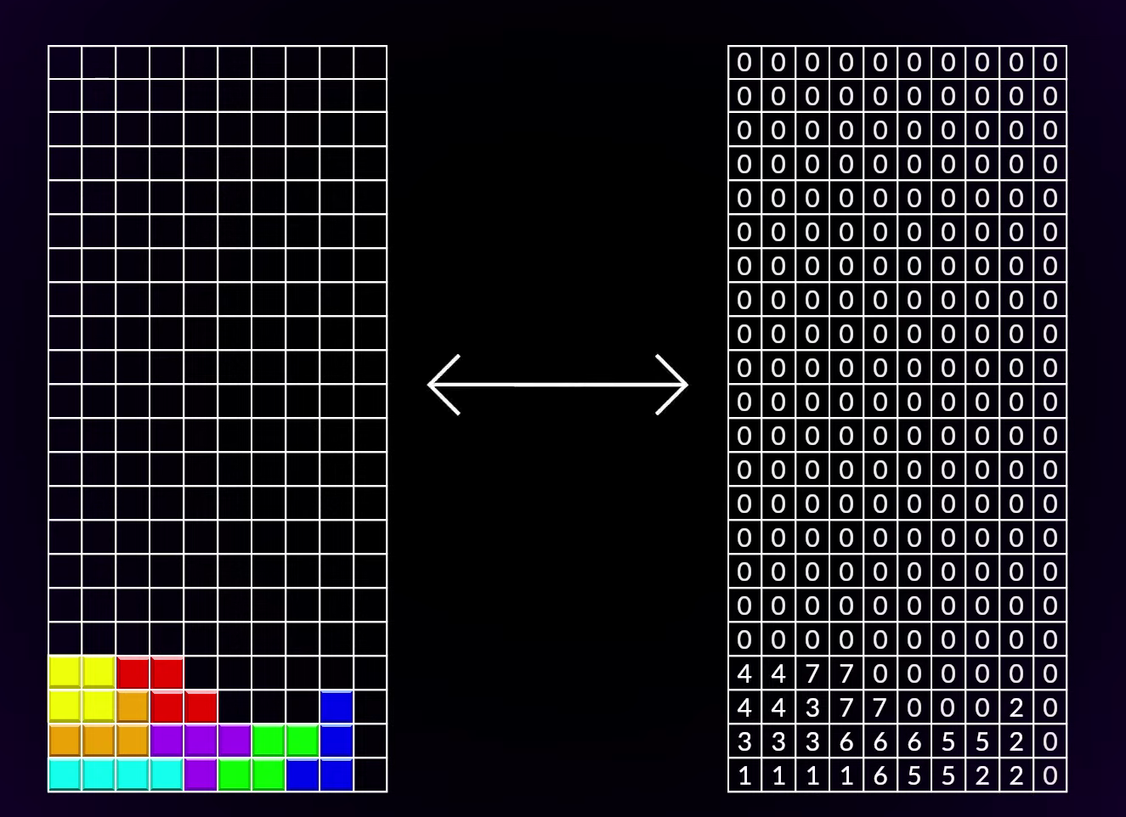

* Empty cells are represented with value 0.
* A blue-sky cell is represented with the value 1.
* Blue cell is represented with the value 2.
* Orange cell is represented with the value 3.
* Yellow cell is represented with the value 4.
* Green cell is represented with the value 5.
* Purple cell is represented with the value 6.
* Red cell is represented with the value 7.

NOTE:

We have different types of blocks formed by the clarified colors that is

Step 1: Game Grid.

We create the class called game Grid with 2D array. Th 1st dimensional is a row and the 2nd is the column.

Inside a class we created properties for rows and columns. We also created the functions for rows and columns as shown below.

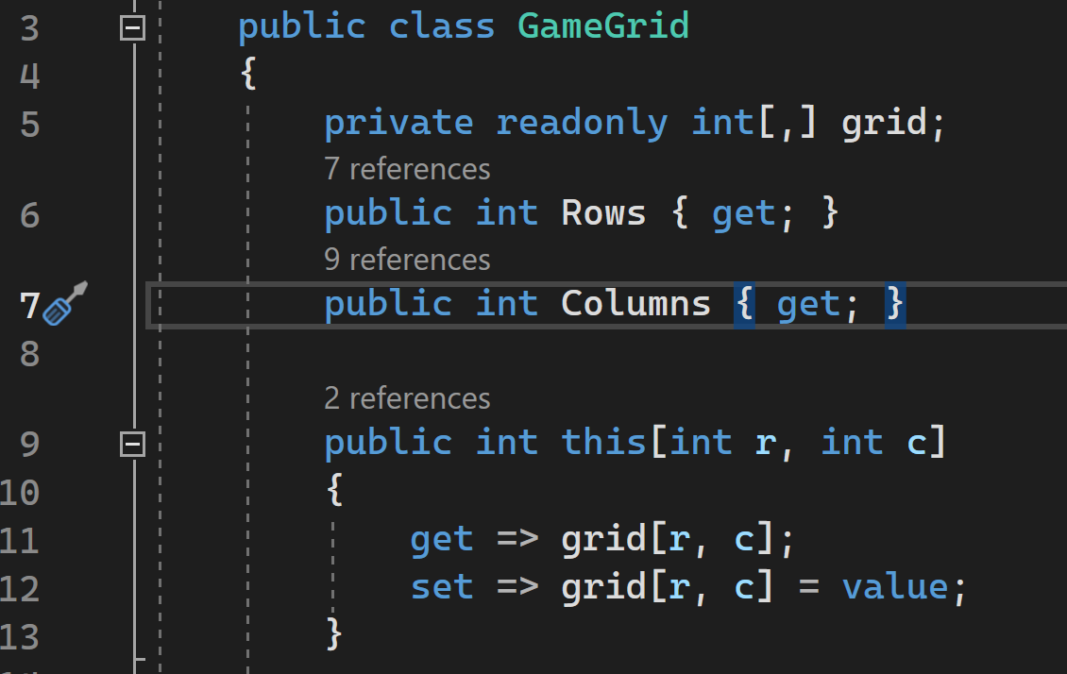

**Sample of functions in our project.**

1. First function check whether the rows and columns are inside the grid or not.

For the rows and columns to be inside the grid should be >=0

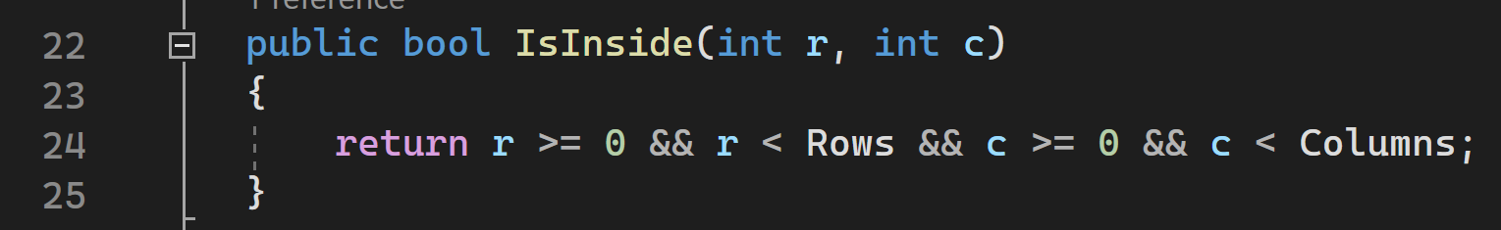

1. It checks whether the given cell is empty or not.

The cell must be inside the grid & the value ==0

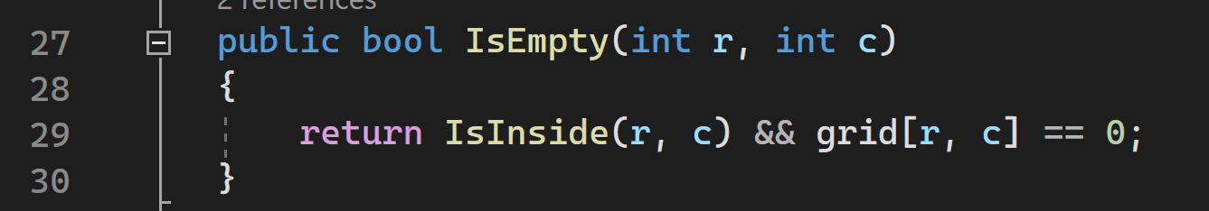

1. It checks whether the row is full or empty.

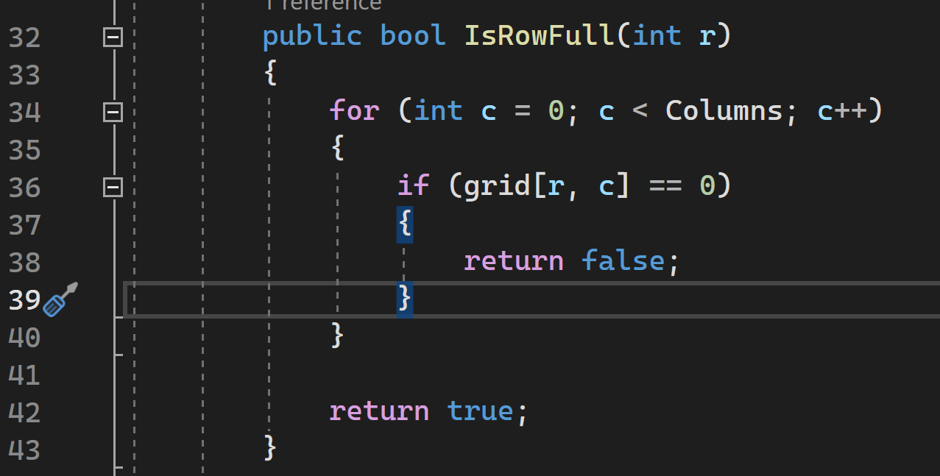

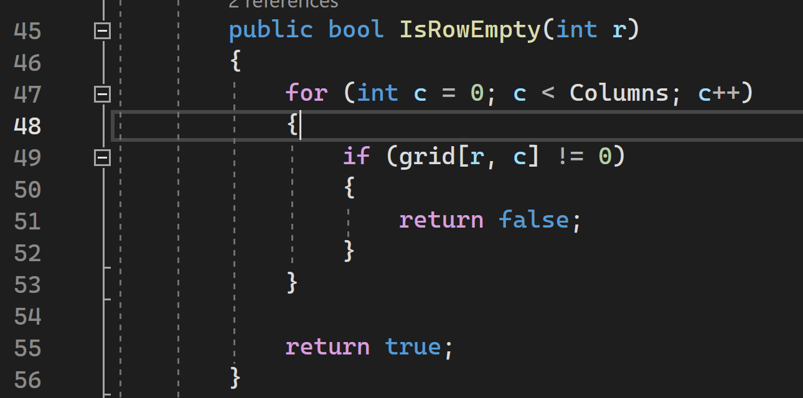

If the rows are full, they need to be cleared and the upper one moved down.

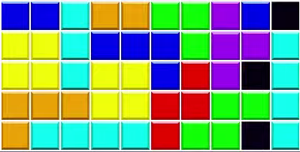

1. The method to clear rows and move the upper one down.

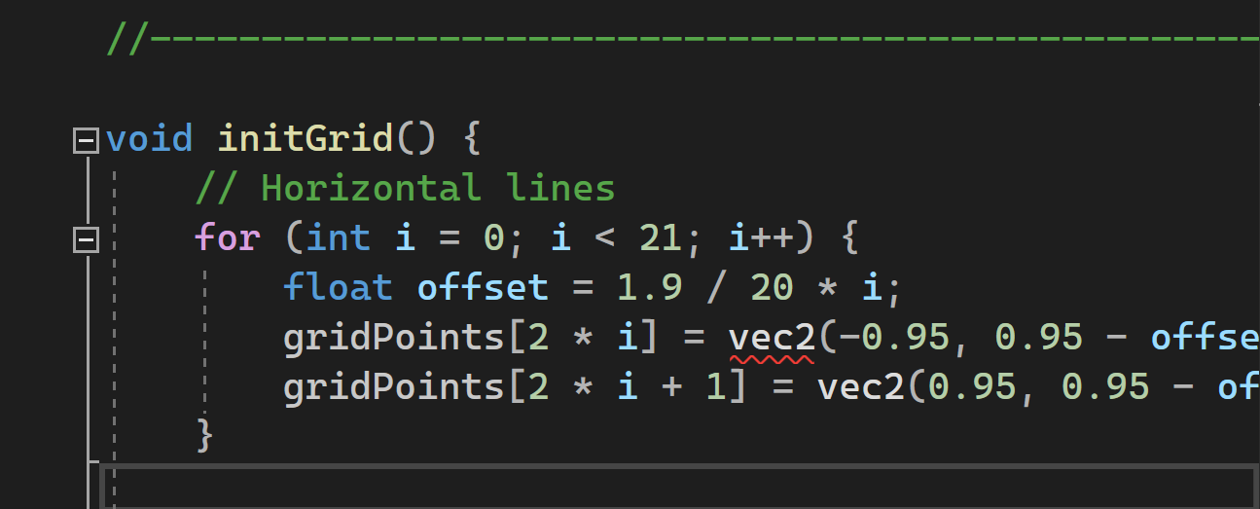

**How it will officially work.**

Once the prayer starts playing, the two dimential grid will show up with the blocks moving down at varying speed. Below is the screen short;

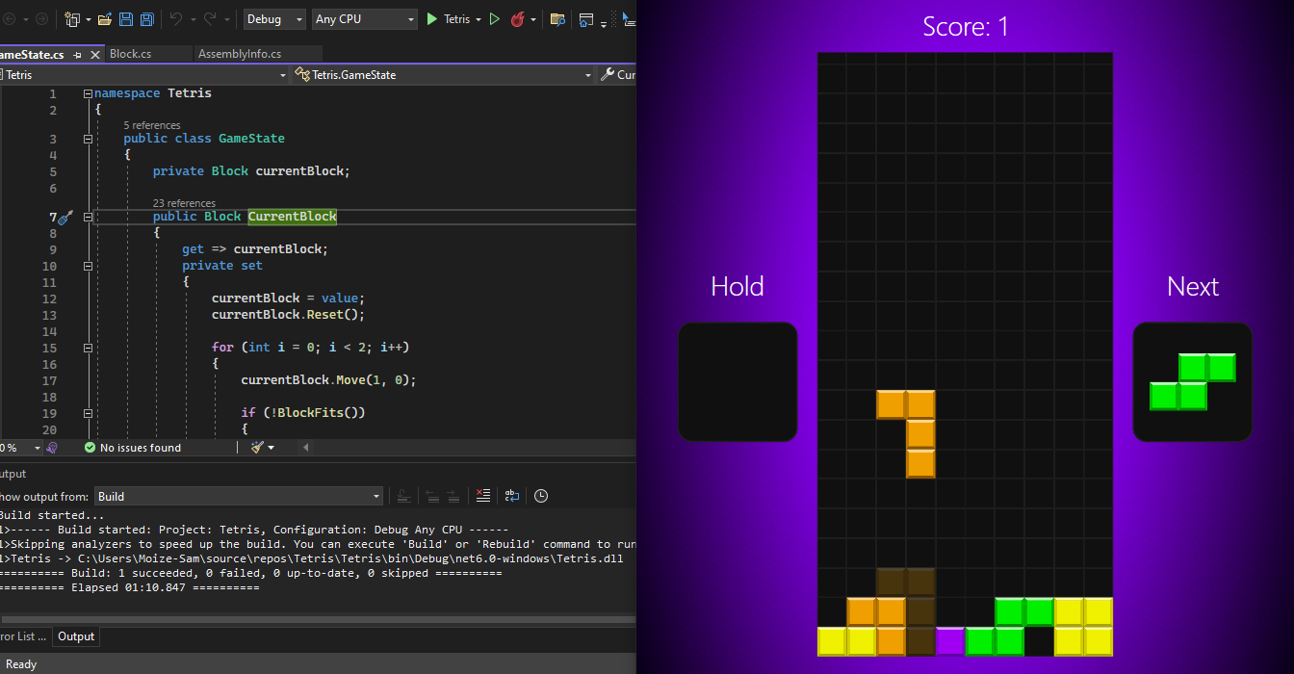

The prayer will use arrow keys to control the direction of the blocks and their positioning’s to get more score. He/she can put the game at hold in case he can’t keep up with the speed.

If, he is not quick he will fail to keep up with the speed of the blocks and the following will happen.

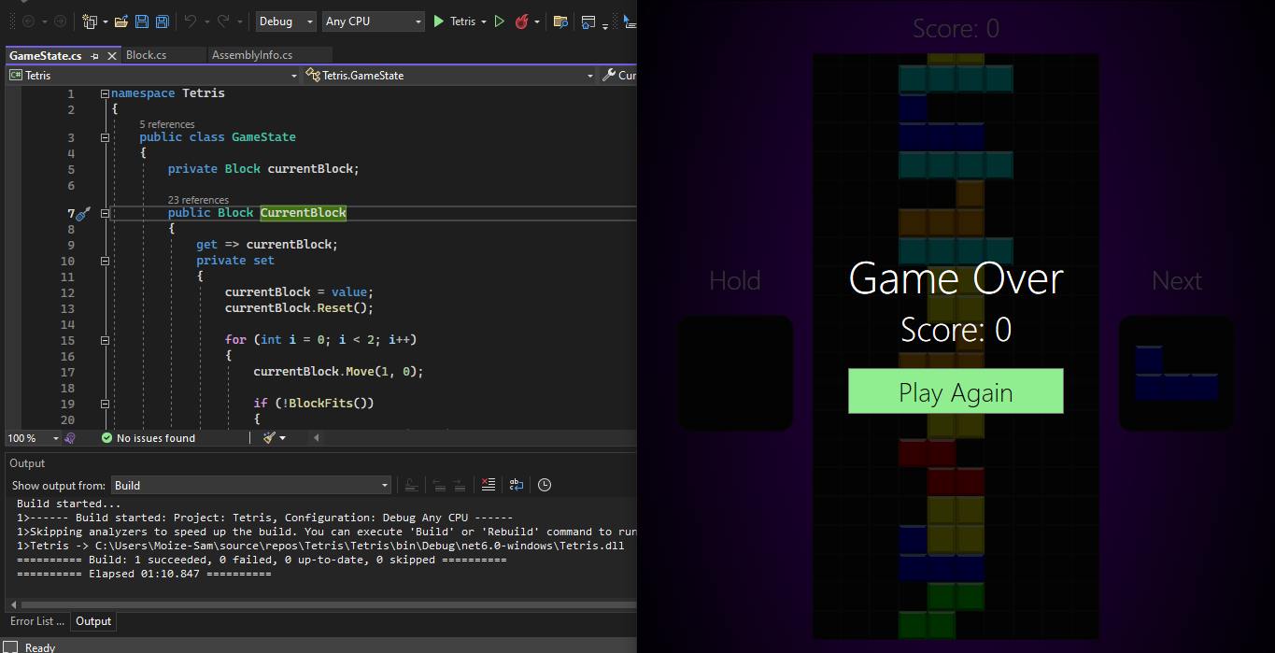

He will run out of space and the game will be over.

In conclusion, the major objectives of the game were achieved that is entertainment and relaxing and the game is working perfectly fine on a two dimensional grid.